REPORT FOR: | OVERVIEW AND SCRUTINY COMMITTEE
Date of Meeting: | 24th February 2015.
Subject: | Report of Short Quality Screening Inspection (SQS) of youth offending work in Harrow undertaken by  HMI Probation
Responsible Officer: | Chris Spencer  Director, Children and Families
Scrutiny Lead Member area: | Councillor Simon Brown, Portfolio Holder for Children Schools and Young People.  Simon.Brown@harrow.gov.uk
Exempt: | No
Wards affected: | Not ward specific
Enclosures: | Report of Short Quality Screening (SQS) of youth offending work in Harrow  Youth Offending Team SQS Action Plan

Section 1 – Summary and Recommendations

Summary
This report sets out the HMI Probation inspection regime for Youth Offending in England and Wales. It summarises the recommendations of Core Case Inspection (CCI) of Harrow Youth Offending Team in 2011, the progress made following that inspection and the findings of the Short Quality Screening (SQS) Inspection of Harrow Youth Offending Team in 2014.

The Action Plan details the steps to be taken to address the recommendations following the SQS Inspection.

There is evidence of significant improvements in performance following the 2011 Core Case Inspection as detailed in the report and the performance data.

The report also provides the changing landscape of youth offending work and the particular challenges which have been addressed and continue to be addressed by the Youth Offending Team.

Recommendations:
To note the contents of the report, the SQS action plan and progress made since the Core Case Inspection in 2011.

Section 2 – Report

Introductory paragraph
Youth Offending Teams throughout England and Wales are inspected by HMI Probation. Since the establishment of Youth Offending Teams in 2000 HMI Probation Inspection regime has evolved from a Youth Offending Team Inspection (YOTI) programme, to a Core Case Inspection programme (CCI). The Core Case Inspection programme of work ended in 2012 and HMI Probation developed a programme of three inspection types, Full Joint Inspection, Thematic and Short Quality Screening.

Between April 2009 to April 2012 all 158 Youth Offending Teams in England and Wales received a Core Case Inspection. In 2011 HMI Probation undertook a Core Case Inspection of youth offending work in Harrow.

In 2014 a Short Quality Screening inspection. was undertaken in Harrow by HMI Probation.

This report considers the progress made since the 2011 Core Case Inspection and the action plan in response to the more recent Short Quality Screening Inspection. It highlights some of the challenges within the service and identifies where progress has been made.

Background .
Multi-agency Youth Offending Teams (YOT) were established in 2000 following the 1998 Crime and Disorder Act with the intention of reducing risk of young people offending and re-offending, and to provide counsel and rehabilitation to those who do offend.

The Youth Justice Board (YJB) has 3 key indicators for all YOTs
Reducing first time entrants to the criminal justice system
Reduce re-offending
Reducing the use of custody

In 2011 HMI Probation undertook a Core Case Inspection of youth offending work in Harrow. The focus of the inspection was the quality of work undertaken with children and young people who offend. A representative sample of youth offending cases (38 cases) were examined to judge how often the Public Protection and Safeguarding aspects of work were done to a sufficiently high level. The 38 cases were made up of first tier (referral orders, action plan and reparation orders), youth rehabilitation orders and detention and training orders and other custodial sentences. Case Managers were interviewed and 34 young people completed a questionnaire for the Inspection.

The findings of the Inspection were
• Substantial improvement was required in the areas of Safeguarding
• Substantial improvement was required in Public Protection (likelihood of reoffending)
• Drastic improvement was required in Public protection (risk of harm).

The Inspection made 9 recommendations for improvement including
• A timely and good quality assessment and plan, using ASSET, is completed when the case starts
• As a consequence of the assessment , the record of the intervention plan is specific about what will now be done in order to safeguard the young person from harm, to make them less likely to re-offend, and to minimise any identified Risk of Harm to others
• Children and young people, and their parents/carers are actively and meaningfully involved in assessment and planning, including through the timely use of self assessments (what do you think in ASSET), and the assessment of learning styles
• Oversight by management, especially of vulnerability and Risk of Harm to others is effective in ensuring the quality of practice and provision of services, and is clearly recorded within the case record
• Purposeful home visits are undertaken, as appropriate to the needs of the case and consistent with Safeguarding needs and the Risk of Harm to others.

The implementation of the action plan in response to the inspection was overseen by the multi agency Youth Offending Management Board which met on a monthly basis to monitor progress.

Changing context since the inspection in 2011.

Staffing in the Youth Offending Team.
Following the inspection in 2011 additional staff including 2 Case Managers to manage young people and a Senior Practitioner to provide increased management oversight were appointed.
An experienced Team Manager was appointed to the YOT Team Manager post in 2012. This was following a gap of a number of years when the Team Manager post had been covered by several agency staff.

Performance management was implemented and a challenging action plan was put in place.

A number of staffing challenges have been dealt with.

There has been considerable staff turnover over the past three years at both a practitioner and senior level with an over reliance on agency staff.

The structure of the YOT is currently being reviewed to ensure that it is able to meet the changing youth justice landscape both nationally and locally.

Youth Offending Management Board.
The multi agency Harrow Youth Offending Management Board has also undergone significant changes with Governance being a key aspect of Full Joint Inspections. In recent months the Board has been strengthened with a greater emphasis on youth offending across the partnership, and overview and scrutiny of performance and the delivery of the Youth Offending annual plan.

Information Technology.
The Youth Offending Team uses a data base, YOIS, (Youth Offending Information System) and Connectivity which is used to share information about young people with other YOTs, the secure estate and the YJB. Both systems have been unreliable /unavailable at times over the past 18 months which has impacted on performance. In addition as a result of not being able to consistently provide documents to the YJB through Connectivity when a young person has been remanded/sentenced to custody Harrow is the subject of an action plan with the YJB.

YOIS is an ageing system which is being phased out across all YOTs in 2015.
An alternative data base, Capita 1, has been purchased and is scheduled for implementation in June 2015, with a go live date in July. The concern remains in respect of the IT infrastructure to support the system. In addition with any new data base there are potential implementation problems and the impact of such problems on performance are unkown.

Youth Justice Landscape.
Following the Core Case Inspection in 2011 the youth justice landscape has changed significantly due to changes in legislation and identified outcomes and priorities.
- Reduce first time entrants
- Reduce re-offending
- Reduce the use of custody
- Deliver effective practice in youth justice services
- Safeguarding of children and young people who come into contact with youth justice services
- Protection of the public from harmful activities of children and young people who offend

- Legal Aid and Sentencing and Punishment of Offenders Act (LASPO) came into effect in December 2012 . The Act reformed the justice system and the administration of legal aid and created a new youth remand and sentencing structure that allows courts greater flexibility when deciding on appropriate disposals for young people. This significantly changed the management of young people within the Youth Justice system.
- An increased focus on reducing the number of young people remanded into custody , with a greater emphasis on offering robust and creative bail packages which address the risk and need of each young person
The Act requires that any child remanded into custody from April 2013 is treated as 'Looked After' by the local authority
Changes to “out of court” disposals mean an automatic referral to the YOT for interventions must be offered to young people who have been made the subject of a Youth Conditional Caution , and on a second youth caution the young person must be assessed and offered a voluntary rehabilitation programme.
- The introduction of education requirements as part of a Youth Rehabilitation Order, makes it a statutory requirement for young people on such Orders to attend education or to be in breach of their court order.
- Referral Orders can be used repeatedly.

Youth Justice Board National Standards.
A revised set of Youth Justice Board National Standards were issued in 2013. The National Standards define the minimum required level of service provision to ensure effective delivery of practice, safeguarding of young people in contact with youth justice services, and protection of the public from the harmful activities of young people who offend. An annual audit is undertaken to ensure that the standards are being adhered to and improvements are tracked.
Adherence to the standards is a mandatory requirement and in the future may be linked to the Good Practice Grant.

National Probation Service.
There are also significant reforms to the National Probation Service including the separation of the service into two arms, the National Probation Service (managing high risk within the community ) and the Community Rehabilitation Company (managing medium and low risk) This will potentially impact on those young people who at the age of 18 years transfer to Probation to serve the remainder of their sentence. YOT will be required to develop stronger links to inform appropriate referrals of young people to Probation.

SEND reforms.
The Children and Families Act 2014 transforms the system for disabled children and young people and those with special educational needs (SEN). The new statutory requirements for when a child or young person is detained will come into force on 1st April 2015. In effect YOT and social worker (if there is one) are responsible for the young person’s special educational provision whilst in custody and for support to be put into place immediately on release and to review the provision on release.

Unpaid work.
Responsibility for the delivery of unpaid work transferred in 2014 from the national Probation Service to Youth Offending Teams. From 2015 unpaid work is required to have greater emphasis on skill acquisition and qualifications but retaining the punitive side of the order. It is proposed that this will be delivered in partnership with one of our partners. This is an additional demand upon YOT to identify and support appropriate unpaid work.

Serious youth crime.
There has been an increase in serious youth violence and youth crime in Harrow and across London.

Increased intensity levels.
The Youth Offending Teams has experienced an increase in the numbers of young people who have been assessed as high risk/high risk of vulnerability, which requires an increase in the frequency of the statutory contacts the YOT has with the young person.

36.1%. of interventions are Intensive, (seen minimum three times a week)
44.3% are enhanced (seen minimum once a week)
19.7% are standard, (seen once a fortnight).

Current situation
The most recent Short Quality Screening (SQS) Inspection of Harrow YOT was undertaken over two and a half days in October 2014.

This is a very different inspection to the Core Case Inspection in terms of the scope of the inspection and the number of cases inspected. It is therefore not possible to compare the findings of the two inspections, as they inspected different aspects of youth offending. The focus of SQS inspection is of the quality of work at the start of the sentence in a small number of recent cases with young people who have offended, through to the point when initial plans should have been in place post-sentence. The records of 14 young people were assessed comprising first tier cases, community cases and young people in custody.

The Inspection highlighted 3 areas for improvement.
- Significant improvement is needed to improve the overall quality of management oversight in order to drive up the quality of assessment, planning and review.
- Measures to improve the quality and consistency of safeguarding and vulnerability work, at both management and practitioner level, needs to be implemented urgently.
- In order to support improvement in staff practice and performance, personalised training and induction plans should be in place, specifically addressing; assessment; planning; MAPPA; and speech, language and communication needs.

The action plan to address the recommendations of the SQS inspection is being overseen by the Youth Offending Management Board. It has also been scrutinised by the Safer Harrow Partnership and the Local Safeguarding Children’s Board. It has been shared with the Youth Justice Board who have provided additional support to deliver the action plan.

Why a change is needed.
The SQS identified 3 key areas for improvement as detailed above. Continuing implementation of LASPO.

There continue to be a number of key challenges
- Ensuring that high performance is achieved and maintained
- Compliance with the YJB guidance for referral Orders and Youth Offender Panels (2012) including the recruiting, training and supporting of panel members, engaging and supporting victims and ensuring Referral Order Panels take place within 20 working days of the young person being sentenced
- Ensuring a range of Reparation activities are available in a timely manner so that young people are aware of the impact their offending has on their community and enable them to make amends.
- An effective staff group with the skills and abilities to meet the changing youth offending landscape
- Creative delivery of unpaid work
- Further develop an effective relationship with the Court

Implications of the Recommendation

Financial Implications
Harrow Youth Offending Team has been resourced by contributions from Harrow Council, statutory partners, the Youth Justice Board and some additional grant funding for example the Restorative Justice Development Grant. Statutory partners have also contributed through deployment or secondment of key personnel, including 2 Police officers, 1 Probation Officer and a mental health worker.
The SQS action plan does not have any additional financial implications.

Staffing/workforce.
The SQS action plan has identified specific issues for practitioners and managers which are to be addressed through supervision, training and development, and annual appraisal.

Legal comments.
The new youth sentencing and remand provisions are contained in the Legal Aid, Sentencing and Punishment of Offenders (LASPO) Act 2012. Sections 79-84 deal with referral and rehabilitation orders. Sections 91 to 107 and Schedule 12 make significant changes to the remand framework for 10 to 17 year olds in criminal proceedings.

Where a child/young person has been remanded on bail, the provisions of Bail Act 1976 continue to apply but where a child/young person has been remanded in custody the new framework introduced by section 91 of the LASPO will permit the court to remand a child to local authority accommodation or to youth detention accommodation.

Sections 70-75 of the Children and Families Act 2014 set out the statutory requirements for the provision on services for children/young people with special educational needs who are detained

Performance Issues

The Harrow Council Corporate Plan (2014-2015) priority is “to become the safest borough in London by reducing the overall level of crime and incidences of anti-social behaviour through
- Work to reduce the fear of crime
- Strengthen the links between the anti-social behaviour teams and their links with the youth offending team

The Youth Justice Board has identified 3 outcome indicators for all Youth Offending Teams
- Reduction in the number of first time entrants to the youth justice system
- Reduction in re-offending
- Reduction in the use of custody

In addition the Harrow Youth Offending Management Board receives regular performance reports in respect of the youth offending team. These reports include
- First time entrants and the type of order
- Number of ASSETs (assessment) completed
- Number of Pre-sentence reports (PSR)
- % of interventions with plans created
- % of risk management and vulnerability management plans countersigned
- % of new interventions with a home visit
- Proportion of what do you think forms
- Number of young people remanded into custody
- Young people who are known to YOT/CIN/CLA
- Number of young people receiving a custodial sentence
- Ethnicity of young offenders

Current performance demonstrates
- a reduction in first time entrants to the youth justice system from 127 young people in 2011 to 79 young people in 2013.
- a reduction in re-offending rates from 41.6% (99 out of 238 young people) to 35% (70 out of 200 young people)
- a reduction in the number of remand nights to Young Offenders Institution (YOI) from 398 in 2013/14 to 13 April-Dec 2014 with a corresponding significant reduction in the cost of remand beds
- a reduction in the number of remand nights to Secure Training Centres (STC) from 403 in 2013/14 to 50 April-Dec 2014 with a corresponding significant reduction in the cost of remand beds
- a reduction in the numbers of young people sentenced to custody. In
2011-12 16 young people were in custody compared to 10 young people in 2013-14.
- 95% of ASSETs completed within 15 days (Quarter 3)
- 95.2% of home visits undertaken (Quarter 3)
- 100% of what do you think forms (Quarter 3)
- 100% of plans countersigned by managers

Environmental Impact
None.

Risk Management Implications
Risk included on Directorate risk register? No

Separate risk register in place? No

Failure to implement the action plan to address the recommendations from the Inspection would adversely impact on outcomes for young people and future inspections.

Equalities implications
An EqIA has not been completed as this is an information item.

Council Priorities
The Council’s vision:

Working Together to Make a Difference for Harrow
The administration’s priorities.
- Making a difference for the vulnerable
- Making a difference for communities
- Making a difference for local businesses
- Making a difference for families

Section 3 - Statutory Officer Clearance

 |  |  | on behalf of the*
Name: Jo Frost |  |  | Chief Financial Officer
Date: 27/01/15

 |  |  | on behalf of the*
Name: Lanna Childs |  |  | Monitoring Officer
Date: 30/01/15

Ward Councillors notified: | NO

Section 4 - Contact Details and Background Papers

Contact: Ann Garratt
Service Manager
0208 736 6976

Background Papers:
Report of Short Quality Screening (SQS) of youth offending work in Harrow.

Youth Offending Team SQS Action Plan.

Appendix One

Youth Offending Supporting Data

Quarterly Performance Targets

Number | Description of Measures/Indicators | Target
1 | Initial Assessment  % of interventions staring in period with start ASSET's Completed within 15 days of intervention start (20 days for referral orders) | 95%
2 | Intervention Plans  % of interventions starting in period with plans created within 15 days (20 days for referral orders) | 95%
3 | Management Oversight  % of ROSH's completed in period which were countersigned | 95%
4 | Management Oversight  % of RMP's and VMP's started in the period which were countersigned | 95%
5 | Home Visits  Of those appropriate for Home Visits, % having them within 28 days of the intervention start | 90%
6 | What do you think forms  Proportion of current interventions having 'What do you think forms', which were recorded on the system. | 95%
7 | Education, Training & Employment (ETE)  Proportion of caseload who are currently 'Actively Engaged' in education, training and employment (ETE). (25+hrs for statutory school age and 16+ hrs for 17-18 year olds) This figure does not include those in custody. | 75%

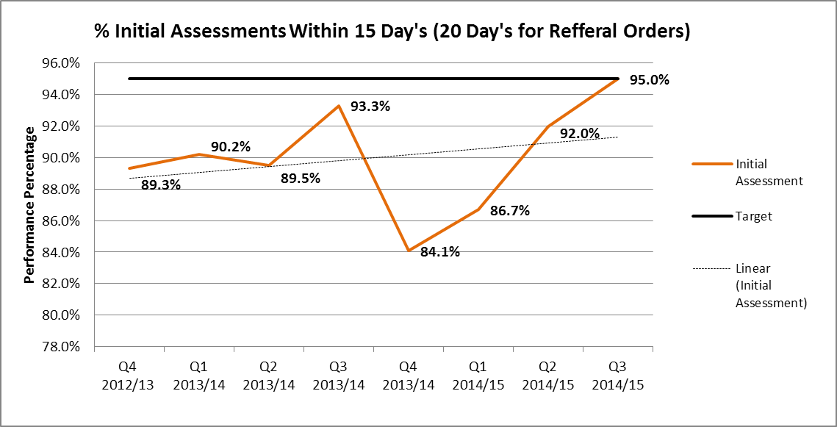

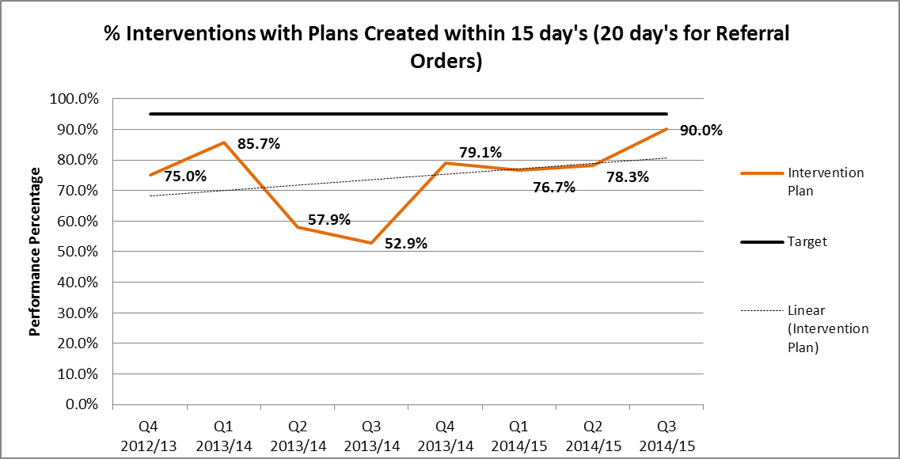

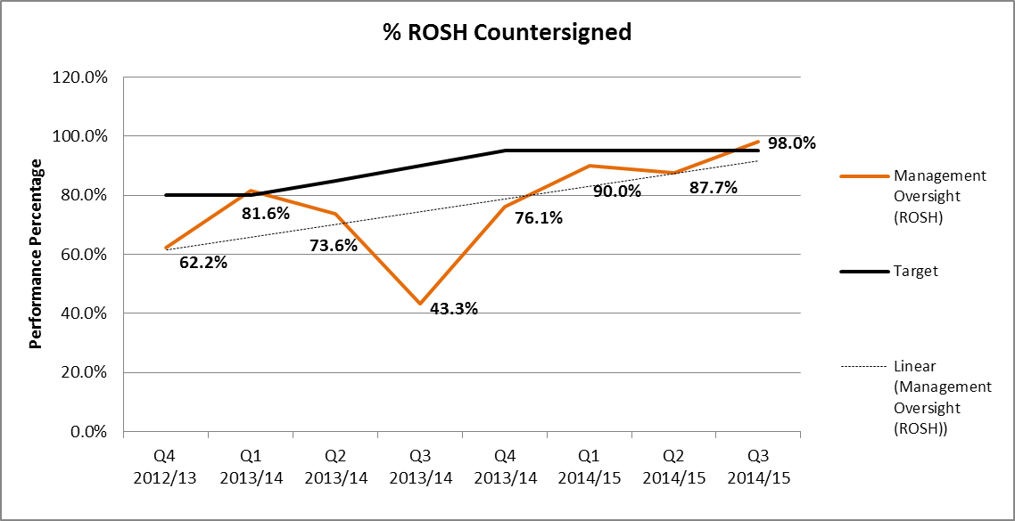

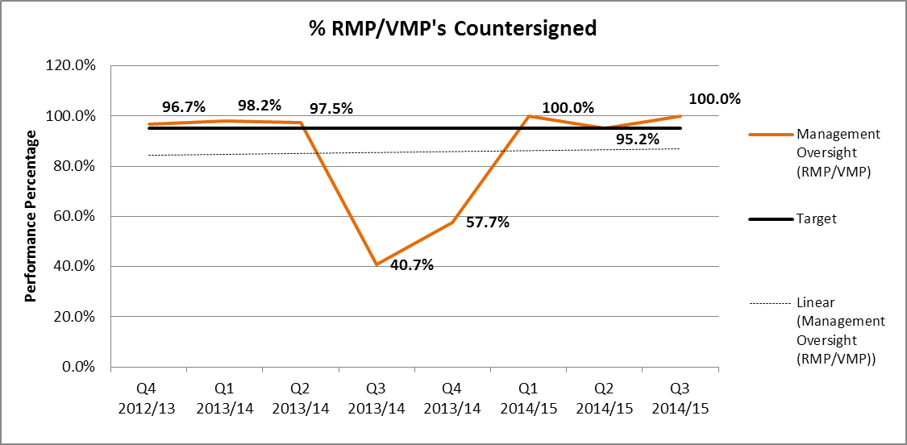

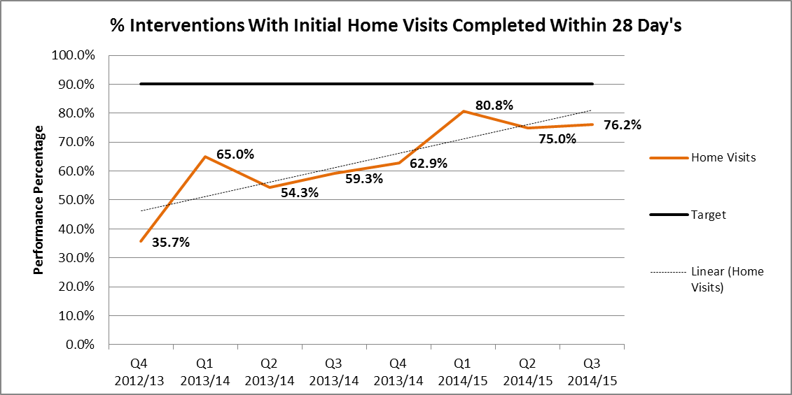

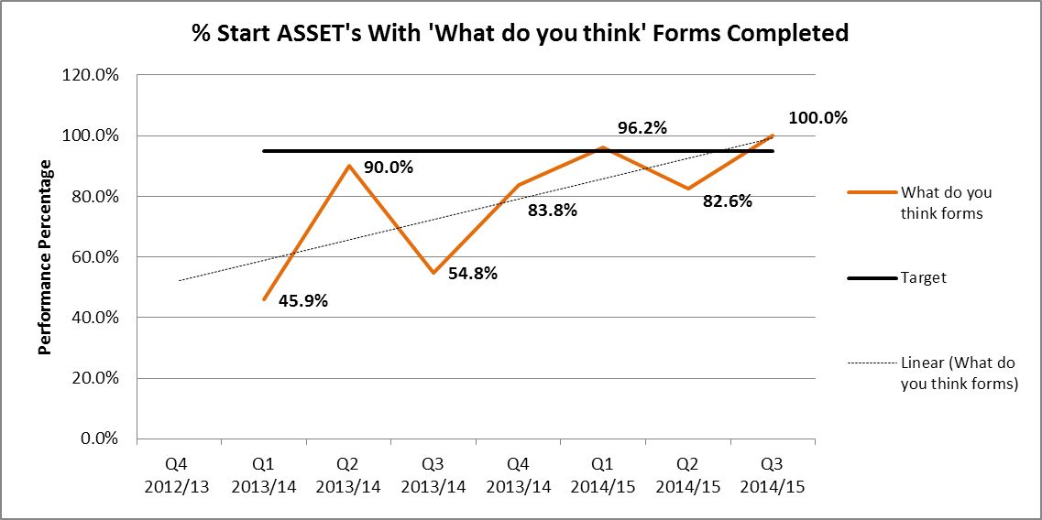

Young people committing crime

Table 1: Harrow Offences and Disposals – 3 year comparison
 | Offences |  | Disposals
 | Total Offences | % Change | No. of Pre-court  disposals | No. of First-tier  disposals | No. of Community disposals | No. of Custody  disposals | Total Disposals | % change from previous year
April 2013 – March 2014 | 301 | 12.3% | 25 | 100 | 78 | 10 | 213 | 18%
April 2012 - March 2013 | 268 | -27.4% | 5 | 78 | 77 | 20 | 180 | -32%
April 2011 - March 2012 | 369 | -10.0% | 19 | 152 | 78 | 16 | 265 | -5%
April 2010 - March 2011 | 410 | - | 47 | 128 | 87 | 17 | 279 | -

Overall youth crime had shown a significant decrease in 2012-13 compared to previous years. Which is reflected in the number of offences taking place and the number of individuals committing crime. However, the 2013-14 figure covering the period April to March shows an overall increase compared to 2012-13. Although this has not reached the pre 2012-13 figures.

Total offences had fallen to 240 in 2012-13. Between 2010-11 and 2011-12 there was a 10.0% decrease from 410 to 369. Between 2011-12 and 2012-13 there was a further decrease of 35.0% from 369 to 240. However, there have been a total of 301 offences in 2013-14, compared with the 2012-13 figure of 268, which represents a 12.3% increase on 2012-13.

The total number of young people who have been found guilty of a crime had fallen overall between 2010/11 and 2012/13. In 2010/11 this was 162 individuals, rising to 174 in 2011/12, which represents a small increase of 7.4%. In 2012/13, this figure fell to 111, a significant decrease of 36.2%. However, there have been a total of 133 young people found guilty in 2013-14, this compared with the 2012-13 figure of 117 represents a 13.7% increase.

There were a total of 213 disposals granted in the year compared to 180 in 2012-13, this represents an 18% increase.

First Time Entrants

The data for first time entrants to the youth Justice Service relates to proven offences, where a young person is given a formal out of court or court disposal. Figures are based on data from the police national computer (PNC) and are given as a rate per 100,000 population (10-17). The figure used covers a 12 month reporting period which runs from January to December.

An offence is defined as a first offence if it results in the person receiving their first reprimand, warning, and caution or court conviction – i.e. they have no previous criminal history recorded on the PNC.

Table 2: First time entrants to the Youth Justice Service 2005 - 2013
First Time Entrant to Youth Justice Services – Per 100,000 (10-17) Population
 | 2005 | 2006 | 2007 | 2008 | 2009 | 2010 | 2011 | 2012 | 2013
Harrow | 956.60 | 1029.20 | 1032.70 | 1092.10 | 827.10 | 647.70 | 523.30 | 335.80 | 334.60
London | 1523.30 | 1762.00 | 1771.90 | 1561.70 | 1285.80 | 983.10 | 795.90 | 591.30 | 458.20
Statistical Neighbours | 1397.42 | 1638.91 | 1655.05 | 1352.89 | 1214.84 | 819.52 | 687.28 | 508.58 | 408.49
England | 1942.50 | 2000.10 | 1939.70 | 1534.80 | 1228.40 | 901.70 | 725.60 | 556.00 | 440.90

Chart 1: First time entrants to the Youth Justice Service 2005 – 20132

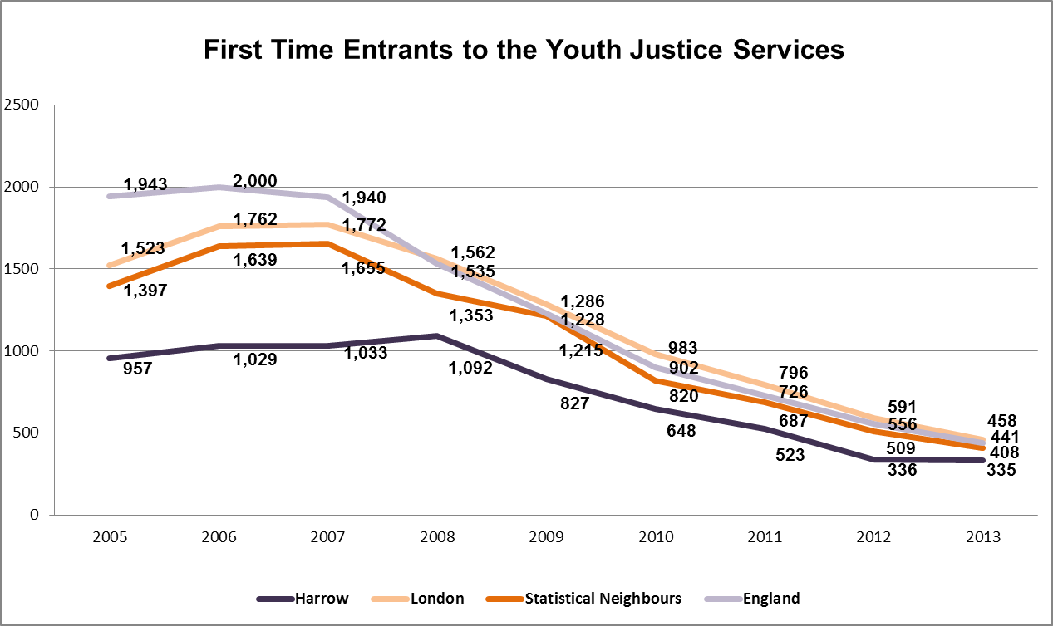

Since 2007 the national trend has been a year on year decrease in the number of first time entrants to the youth justice system. The national trend is reflected in Harrow’s figures which decreased from 1,092 in 2008 to 335 in 2013. Harrow has consistently performed well against National, London and Statistical Neighbour averages. There has been only a slight decrease between 2012 (336) and 2013 (335) which may suggest that numbers are levelling out.

In total Harrow had 79 first time entrants during 2013 (Jan 13 – Dec 13) this is slightly down from 81 in 2012 and 127 in 2011.

Re-offending Figures

Table 3: Proportion of young offenders who re-offend 2005 – 20123
Proportion (%) of Young Offenders Who Re-offend 2005 - 2012
 | 2005 | 2006 | 2007 | 2008 | 2009 | 2010 | 2011 | 2012
Harrow | 29.50 | 30.10 | 31.50 | 29.90 | 33.20 | 33.00 | 39.50 | 39.90
Statistical Neighbours | 32.32 | 31.52 | 31.95 | 32.71 | 33.04 | 35.17 | 36.20 | 38.66
England | 33.60 | 33.90 | 32.50 | 32.90 | 32.80 | 35.30 | 35.90 | 35.70

Chart 2: Proportion of young offenders who re-offend 2005 – 20123

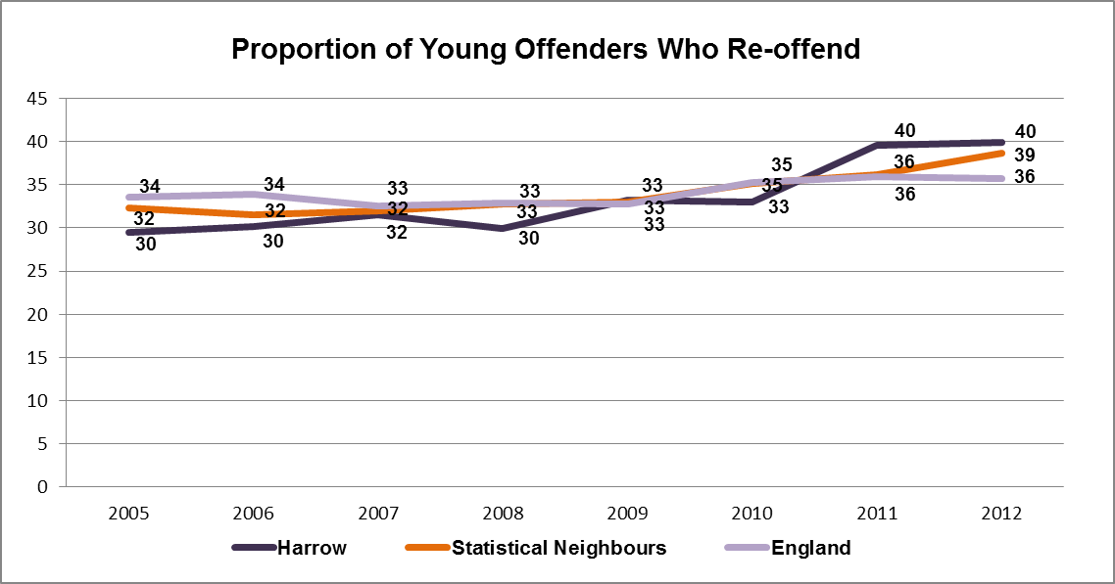

On a national scale re-offending has seen a steady increase in the proportion of re-offenders between 2005 and 2012. However, the size of the cohort from which re-offending has been measured has been decreasing year on year with particular reductions among those young people who have had no previous offences. This has left a smaller, more challenging group within the youth justice system which is reflected in a higher rate of re-offending.

Harrow has followed the national trend with the proportion of re-offenders increasing steadily since 2005. Although, since 2010 harrow’s rate of re-offending has moved above national and statistical neighbours for the first time. This is likely due to harrow’s levels of first time offenders reducing at a faster rate during those periods.

Harrow’s 2012 figure for re-offending representing the period between Jan 11 – Dec 11 was 39.95% (63 re-offenders out of a cohort of 158 offenders) which is in line with the 2011 figure of 39.50% (85 re-offenders out of a cohort of 215 offenders). Although the proportion of re-offenders has remained stable between 2011 and 2012, the 2012 figure represents a smaller cohort with 63 re-offenders compared to 85 in 2011.

Chart 3: Proportion of young offenders who re-offend
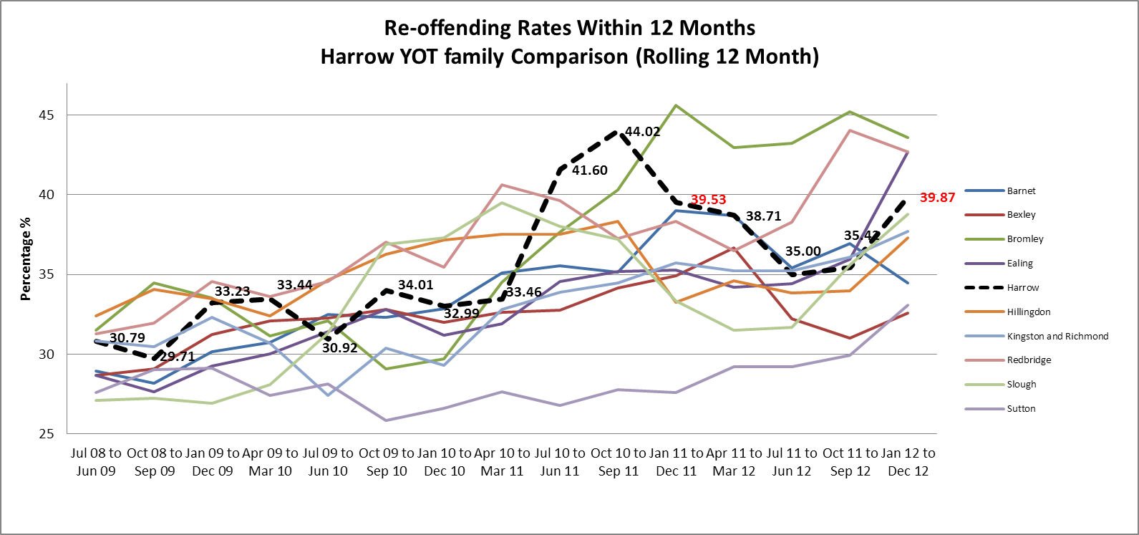

Chart 3 shows Harrow’s re-offending rate in comparison to its statistical Neighbours. The table offers a more balanced view of the changes over time based on a 12 month rolling period. The figures from chart 2 represent the 12 month rolling period between Jan – March which have been highlighted in red in table 3. In contrast to this, there was a significant decrease between Jun10 – Jun 11 (41.6%) and Jun11 – Jun 12 (35.0%).

Custody Figures

Table 4: Number of young people sentenced to Custody

Young People Receiving a Conviction Who Are Sentenced to Custody
 | 2011 | 2012 | 2013 | 2013
Harrow | 0.80 | 0.66 | 0.84 | 0.43
London | 1.57 | 1.69 | 1.04 | 0.99
Statistical Neighbours | 1.08 | 1.07 | 0.76 | 0.61
England | 0.90 | 0.87 | 0.64 | 0.52

Chart 4: Number of young people sentenced to Custody5

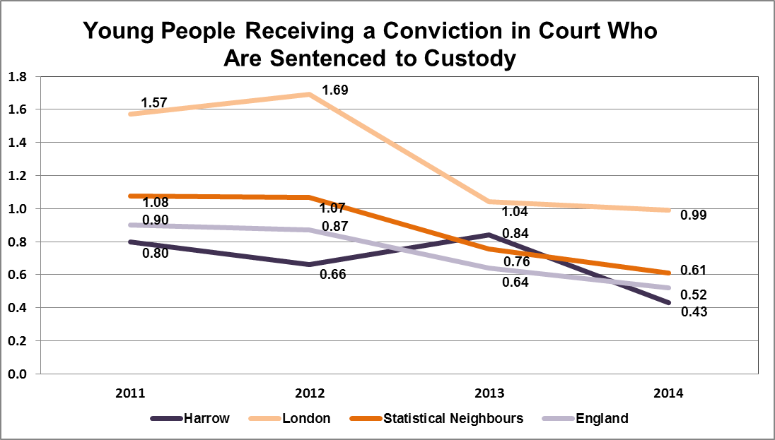

The data for young people sentenced to custody is based on the rate per 1000 population (10-17) sentenced within a 12 month period (April to March).

Over that past four years Harrow’s rate has generally been lower than National, London and statistical neighbour averages, apart from in 2013 where the figure increased to 0.84 which was above both the statistical neighbour averages of 0.76 and the national average of 0.64.

During 2013-14 (April-March) Harrow has had a considerable decrease in the numbers being sentenced to custody in relation to previous years. The actual number for 2013-14 is 10 compared to 20 in 2012-13 and 16 in 2011-12. As a percentage of all disposals in the year, custody represents 4.6% for 2013-14, this is a significant decrease from the 2012/13 figure of 11.1%.

In 2014-15 so far (April-Dec) Harrow has had 7 custodial sentences.

Remand Data

Table 5: Remand Bed Day’s – 3 year comparison
 | 2012/13 | 2013/14 | 2014/15 (YTD)
Number of new remand episodes in year | 17 | 11 | 4
Total STC Bed Day’s | 403 | 182 | 50
Total STC Cost | £244,621 | £105,378 | £28,950
Total YOI Bed Day’s | 398 | 129 | 123
Total YOI Cost | £68,917 | £21,027 | £20,049

There has been a year on year decrease in the use of remands since 2012/13, from 17 in 2012/13 to 11 in 2013/14 and only 4 year to date in 2014/15. This is reflected in a decrease in the cost of remands at a total of £313,538 in 2012/13 compared with only £48,999 in 2014/15 year to date.

YOT and CLA

Table 6: YOT/CLA snapshot
 | Oct 13 | Nov 13 | June 14 | Aug 14 | Dec 14 | Jan 15
Total children involved with YOT | 93 | 102 | 86 | 74 | 71 | 73
Total children looked after | 12 | 13 | 14 | 9 | 6 | 10
%YOT clients currently CLA | 12.9% | 12.75% | 16.28% | 12.6% | 8.45% | 13.7%

The youth offending service monitors YOT/CLA on a regular basis. Table 6 represents the number and proportion of the YOT caseload who are looked after at snapshot’s throughout the past year. The proportion of looked after children on the Youth offending caseload is variable but based on the above snapshot’s, Harrow has an average of 12.8% of its youth offending caseload who are looked after.

Effective Implementation of LASPO

Table 7: Intensive surveillance and supervision requirements – 3 year comparison
Year | Intensive Supervision and Surveillance in year | New Intensive Supervision and Surveillance
2011/12 | 32 | 26
2012/13 | 25 | 15
2013/14 | 13 | 8
April to Dec 14 | 9 | 3

Table 7 compares the number of orders with an intensive supervision and surveillance (ISS) requirement over the past 3 years. The number of new ISS interventions starting year on year has decreased from 26 in 2011/12 to 3 in 204/15 (Year to date).

YJB/MOJ - Youth Justice Annual statistics 12-13 https://www.gov.uk/government/statistics/youth-justice-statistics
DFE – Local Authority Interactive Tool (LAIT) 18/12/2014. https://www.gov.uk/government/publications/local-authority-interactive-tool-lait
YJB/MOJ - Youth Justice Annual statistics 12-13 https://www.gov.uk/government/statistics/youth-justice-statistics
DFE – Local Authority Interactive Tool (LAIT) 18/12/2014. https://www.gov.uk/government/publications/local-authority-interactive-tool-lait

